Year 8 Science

The Human Digestive System.

Use your textbook and your laptop to label the following diagram, colour it in and fill in the table below.
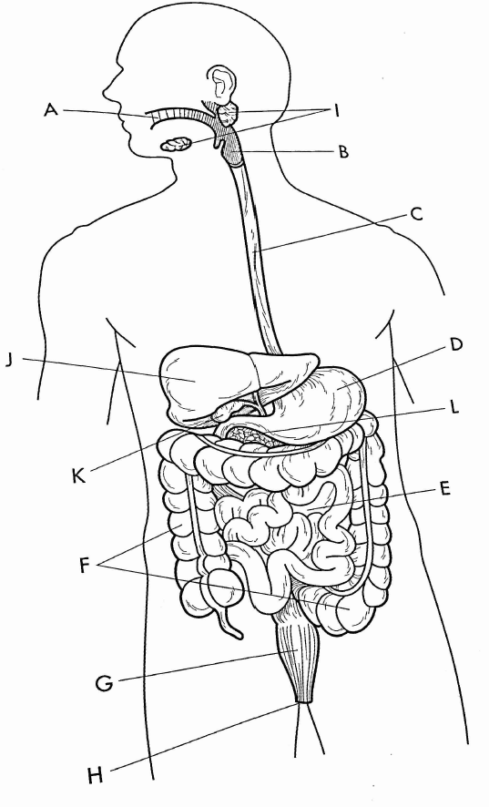
Letter | Colour | Organ’s name | What does it look like? (structure) | What does it do? (function) | What type of digestion is it involved with?
A
B
C
D
E
F
G
H
I
J
K
L

